1. 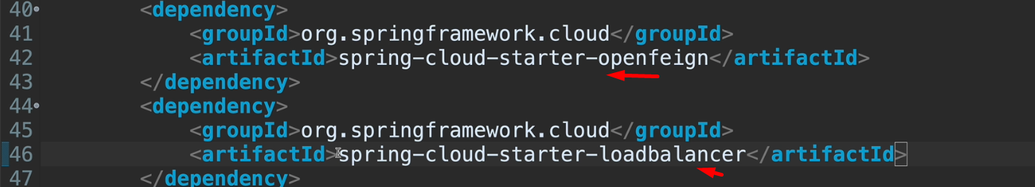
2. 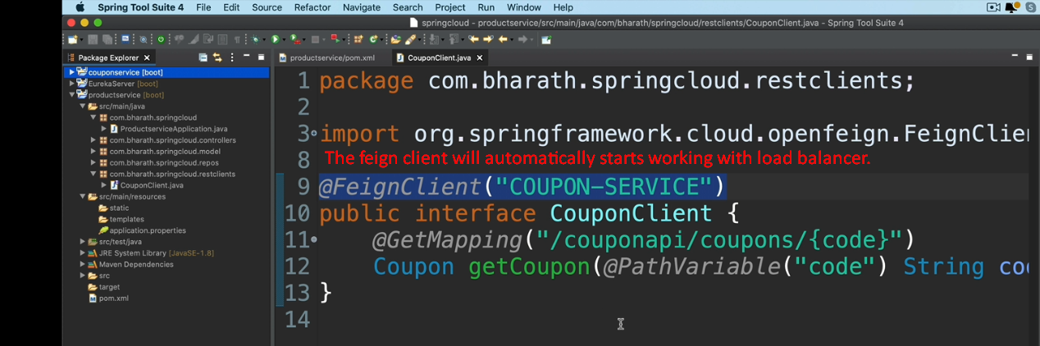
3. 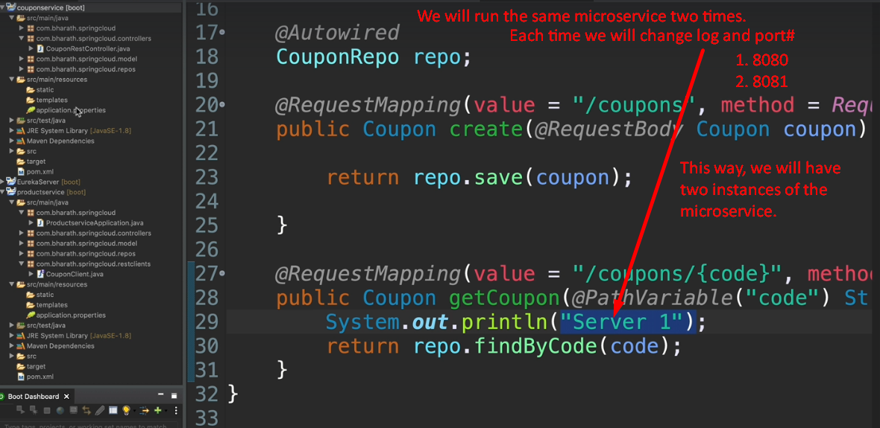
4. 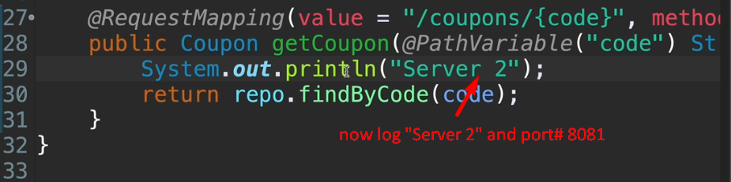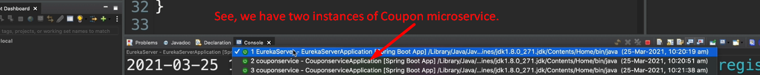
5. Two ways to run multiple instances of a same microservice:
   1. 1st: This way we saw above, where we’re running 2 instances of Coupon microservice on the same machine with different ports.
   2. 2nd: Running on two different machine where port# doesn’t matter then.
6. 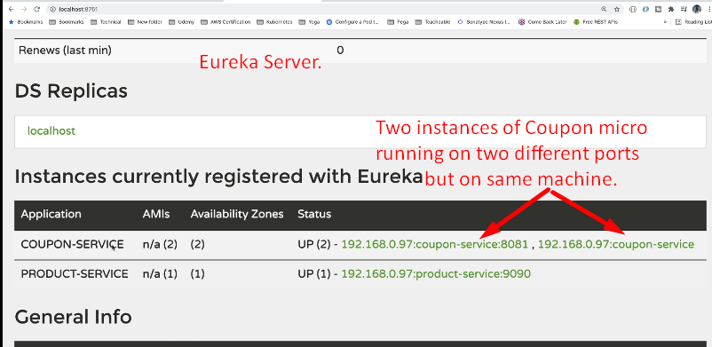
7. 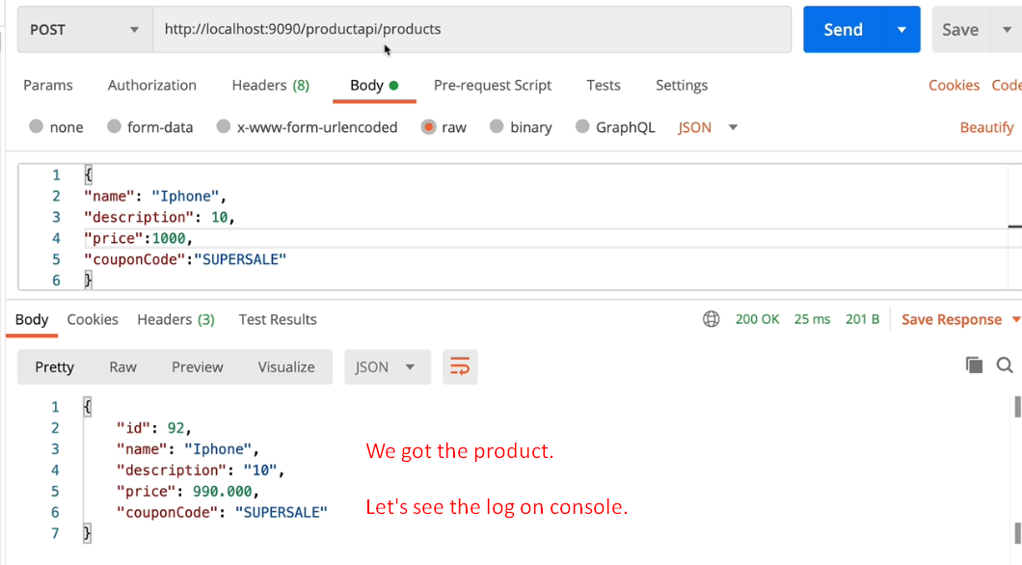
8. 